

DATABASE

SPECIFICATIONS

ITMD 321 Final Project

November, 2020
Revision Sheet

Release No. | Date | Revision Description
Rev. 0 | 11/25/20 | Database Specifications Template and Checklist
Rev. 1 | 11/26/20 | Conversion to .docx format

Database Specifications Authorization Memorandum

I have carefully assessed the Database Specifications for the ITMD 321. This document has been completed in accordance with the requirements of the HUD System Development Methodology.

MANAGEMENT CERTIFICATION - Please check the appropriate statement.

______ The document is accepted.

______ The document is accepted pending the changes noted.

______ The document is not accepted.

We fully accept the changes as needed improvements and authorize initiation of work to proceed. Based on our authority and judgment, the continued operation of this system is authorized.

_______________________________ ___________________
Anthony Irizarry 11/25/2020
Project Leader

_______________________________ ___________________
Reynaldo Gutierrez 11/25/2020
Operations Division Director

_______________________________ ___________________
Tony Acosta Hernandez, Kevin Barrera 11/25/2020
Program Area/Sponsor Representative

_______________________________ ___________________
Anthony Angeles, Ryan Henderson 11/25/2020
Program Area/Sponsor Director

DATABASE SPECIFICATIONS

TABLE OF CONTENTS

Page #

1.0 GENERAL INFORMATION 1-1

1.1 Purpose
1.2 Scope
1.3 System Overview
1.4 Project References
1.5 Acronyms and Abbreviations
1.6 Points of Contact
1.6.1 Information
1.6.2 Coordination
1.6.3 Additional Points of Contact
1.6.4 Data Owners
2.0 DATABASE IDENTIFICATION AND DESCRIPTION
2.1 Naming Conventions
2.2 Database Identification
2.3 Systems Using the Database
2.4 Relationship to Other Databases
2.5 Schema Information
2.5.1 Description
2.5.2 Physical Design
2.5.3 Physical Structure
2.6 Data Dictionary
2.7 Special Instructions
3.0 DATABASE ADMINISTRATIVE INFORMATION
3.1 Responsibility
3.2 System Information
3.2.1 Database Management System (DBMS) Configuration
3.2.2 Hardware Configuration
3.2.3 Database Software Utilities
3.2.4 Support Software Available for Maintaining Database
3.2.5 Security
3.3 Storage Requirements
3.4 Recovery
3.5 Partition/File Information
3.5.1 Content
3.5.2 Description
3.5.3 Partition/File Interdependencies
3.6 Database Interfaces
3.6.1 Description of Operational Implications
3.6.2 Description of Data Transfer Requirements
3.6.3 Description of Formats of Data
3.7 Error Handling

1.0 GENERAL INFORMATION

- GENERAL INFORMATION

1.1 Purpose

This database is designed to show crimes and various nefarious acts that range from physical crimes, terror acts, and criminal acts in the United States.

1.2 Scope

The database will be able to capture crimes and nefarious acts across the United States by pulling data from the Global Terrorism Database (GTD) as well as specific city government databases, and then compiling that data for easy visibility.

1.3 System Overview

This respective system will be a database that contains data from the Global Terrorism Database. There will be four distinct roles within the database and they are end-user, database administrator, client and testing.

- Responsible Party: ITMD 321
- System Name: Global Terrorism Database
- System Code: A1-001
- System Category: General Support System
- Major application: performs clearly defined functions for which there is a readily identifiable security consideration and need
- General support system: provides general ADP or network support for a variety of users and applications
- Operational Status: Under Development
- Operational
- Under development
- Undergoing a major modification
- System Environment: SQL Workbench

1.4 Project References
- NIST Special Publication 800-53 (Rev. 4)
- Global Terrorism Database
- HUD Database Design Specifications

1.5 Acronyms and Abbreviations

- NIST - National Institute of Standards and Technology
- GTD - Global Terrorism Database
- SQL - Structured Query Language
- ITMD - Information Technology Management Development
- Rev - Revision

1.6 Points of Contact

1.6.1 Information

Provide a list of the points of organizational contact (POCs) that may be needed by the document user for informational and troubleshooting purposes. Include type of contact, contact name, department, telephone number, and e-mail address (if applicable). Points of contact may include, but are not limited to, helpdesk POC, development/maintenance POC, and operations POC.

Project Leader Anthony Irizarry
Contact Type: Internal Dep: Development Phone: 313-993-2342

Operations Division Director Reynaldo Gutierrez
Contact Type: Internal Dep: Development Phone:773-343-2375

Program Area/Sponsor Representative Kevin Barrerra
Contact Type: Internal Dep: Management Phone: 313-985-0298

Organization Manager Maurice Dawson
Contact Type: External Dep: Management Phone: 313-985-0298

1.6.2 Coordination

No coordination between outside organizations required.

1.6.3 Data Owners

- University Of Maryland - Global Terrorism Database owners

2.0 DATABASE IDENTIFICATION AND DESCRIPTION

- DATABASE IDENTIFICATION AND DESCRIPTION

2.1 Naming Conventions

The database will be named according to the MySQL naming conventions, as this will make it much easier to do things such as run queries. The tables within the database are representative of specific cities/locations that have crime data associated with them, therefore the table name will contain the specific location. An example of a table name within the database is “omaha_crime_2020_prosecution”, the first piece is representative of the location, the second piece is the nefarious act, the third is the year(s) of the respective dataset and the final piece specifies what the dataset is about. It is all lowercase lettering as SQL is case sensitive and spaces are not present due to possible issues when running queries.

2.2 Database Identification

The database will be identified as “ITMD321Crime.mwb” which will be the unique .mwb file (MySQL Workbench).

2.3 Systems Using the Database
The system(s) that will be using the database will be a Ubuntu Virtual Machine that is running MySQL Workbench, in which workbench files will be generated.

2.4 Relationship to Other Databases

Database will not interface with any other database.

2.5 Schema Information
The structure of this specific database will be as follows:

- Sorted by the type of activity that occurred (terrorist act, domestic crimes, etc..)
- Will then be sorted by the specific location (city, territory, state, etc…)
- Tables will be linked amongst the cities in common
- Allows for future improvements such as to having different cities relate through the crimes committed

2.5.1 Physical Design
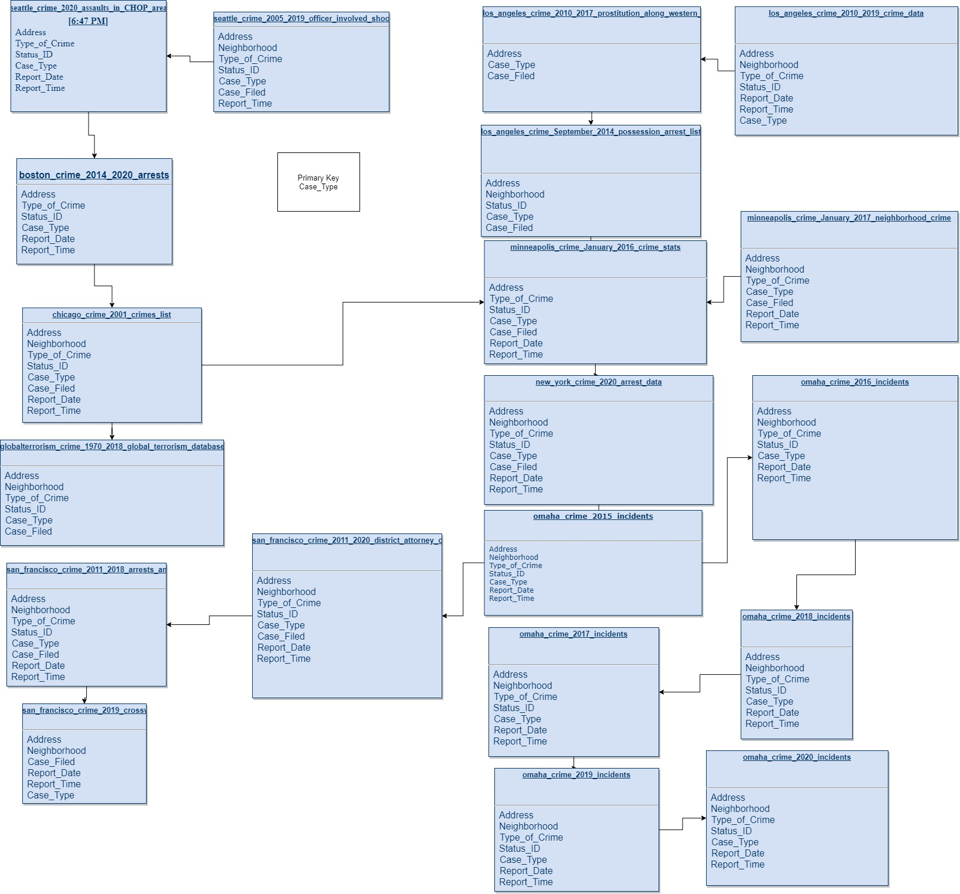

2.6 Data Dictionary

Data dictionary will not be used for this database.

2.7 Special Instructions
- For ease of use, database must be launched and viewed with MySQL Workbench
- To edit any data present within the database or add more, use the Database Administrator role (it allows for any type of editing)
- Back-up the database regularly, as certain entries can cause possible corruption
- Refer to this document for any other specifications regarding the structure of said database
- SQL is the language used to run queries within the database
- Data MUST be in .csv or .txt format

3.0 DATABASE ADMINISTRATIVE INFORMATION

- DATABASE ADMINISTRATIVE INFORMATION

3.1 Responsibility
The parties responsible for the administration of this database will be the ITMD 321 group who created it and none else. The database administrator will be responsible for the data that is being entered and removed from the database. The security administrator will audit the database for any potential flaws and weaknesses and will adhere to the proper guidelines for doing so. The system administrator will be responsible for keeping the machines that the server is running on up and free from downtime, they will determine the most efficient machines to run on as well. Every administrator within this pool is to know SQL and must be proficient with MySQL Workbench (running queries, data entry/removal, etc..).

3.2 System Information
Database Management System :
- MySQL 5.7
- MySQL Workbench 8.0.22

Hardware Configuration:
- CISC based AMD processor (8 cores, 16 threads)
- 16 GiB of DRAM
- 20 GiB dynamically allocated storage pool
- Ubuntu 20.04 Virtual Machine
- 10/100/1000 Ethernet Connection
- Uninterruptible Power Supply (1350 VA)

3.2.1 Database Management System (DBMS) Configuration
    - The DBMS will run on any modern OS as long as MySQL Workbench is installed. The preferred software version for each will be shown under “3.2 System Information”.

3.2.2 Hardware Configuration

Permanent Database Hardware Configuration:
- CISC based AMD processor (8 cores, 16 threads)
- 16 GiB of DRAM
- 20 GiB dynamically allocated storage pool
- Ubuntu 20.04 Virtual Machine
- 10/100/1000 Ethernet Connection
- Uninterruptible Power Supply (1350 VA)

3.2.3 Database Software Utilities
- MySQL Workbench - Ease of maintenance and use

3.2.4 Support Software Available for Maintaining Database
This system runs on a virtual machine.
Virtual Box 6.1.16 is the software used to boot up the virtual machine.

The OS used is Ubuntu Desktop 20.04.

The database was created using MySQL Workbench 8.0.21.

For the necessary data cleaning, Zamzar's web service was used.

3.2.5 Security
There will be access controls implemented into the usage of the database such as roles and specific permissions associated with them. These roles will be protected by a standardized username and password combination. Once logged in to the appropriate account, the respective privileges will be granted (such as table creation/deletion).

3.3 Storage Requirements
  - The storage device will perpetually remain the same, in which the primary storage will be in a virtual machine. The necessary storage capacity will remain at around 20GiB of the primary partition, and will be dynamically allocated to allow for future increases. The storage device is a solid state drive as it allows for fault tolerances and high speed data access, any other storage device will not be tolerated for permanent residency of the data.

3.4 Recovery
Since the database is run on a virtual machine there are snapshots that can be taken for back up and before big changes. These states are to be uploaded to a cloud service Google drive.

3.5 Partition/File Information

3.5.1 Content
The only file present in this database is the database itself which contains 20 tables which have crime data embedded within them.

3.5.2 Description
The design and format of the one file (the database) is that of a MySQL Workbench file.

3.5.3 Partition/File Interdependencies
No file interdependencies exist with each other in the database, they can all be independent tables.

3.6 Database Interfaces

This database will not interface with any other software application at this moment.

3.6.1 Description of Operational Implications
Data transfer is a slow process given that it is done one table at a time. This means that the data must be open for an extended amount of time. The permission for data transfer should be given to very well trusted operators for this reason.

3.6.2 Description of Data Transfer Requirements
Data transfer must be done one table at a time, as anything more might crash the system that the database is residing on. There might be other issues such as an inability to decipher which specific table has failed to import. Data transfer must be done within MySQL Workbench to facilitate ease of use and security.

3.6.3 Description of Formats of Data
    - The data that will be entered into the database must be in two specific file formats which are .CSV and .txt. These are the only two file types that will be allowed to be imported into the respective database. There will be issues if proprietary formats are used such as .xlsx are used and conversions may supply their own set of issues. If a conversion is to be done, the database administrator must confirm that the dataset fully imports with no major errors.

